**Work done by: Jilani and Irshad**

**Source: https://learn.microsoft.com/en-us/azure/stream-analytics/set-up-cicd-pipeline**

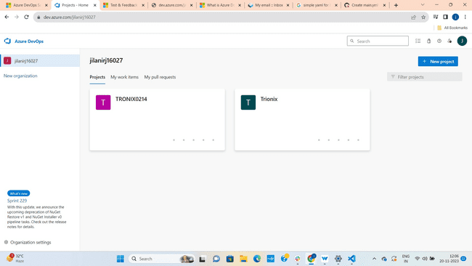



First of all if u don’t have Azure DevOps account Create a Account. If you have a account Login.

Then click on New Project which is present on the top right corner

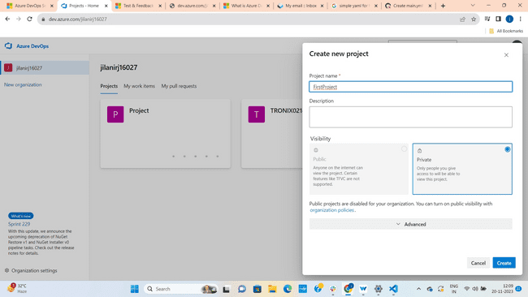



Give Project Name(here we given it as First Project) and click on create.

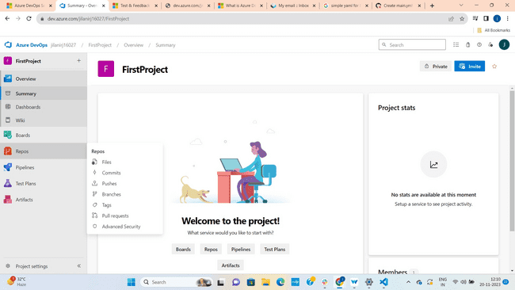



Project is created. Now go to Repos to create a code or else to get a code where the code is present.

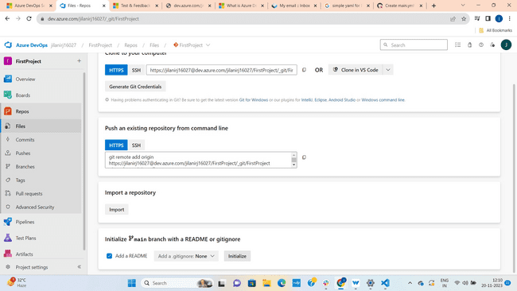



If you have a git hub repository url copy and paste it otherwise click on initialize

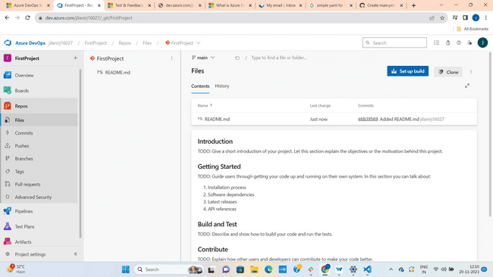



Click on Setup build

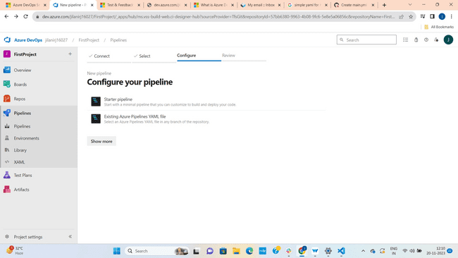



If you have existing azure pipe line click on existing azure pipeline yaml file. If you don’t have select Starter pipeline.

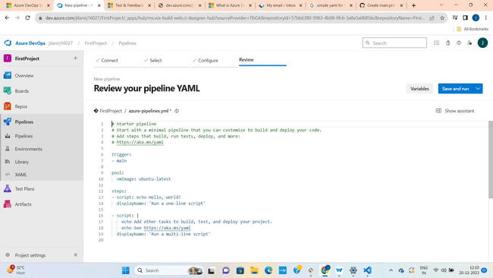



Write the code here. We have taken a simple yaml code from google to print Hello World and pasted it here. Click on Save and Run.

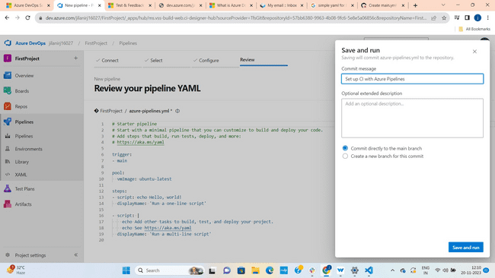



Give a Commit Message as like u need and then click on save and Run.

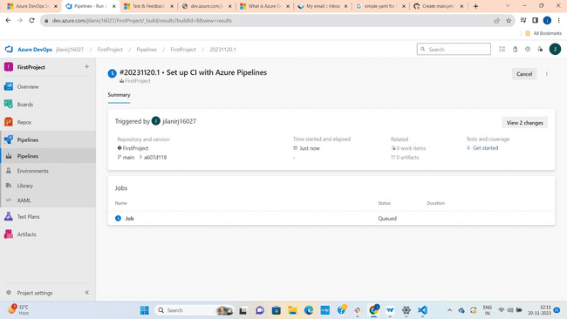



You can see the job is loading.

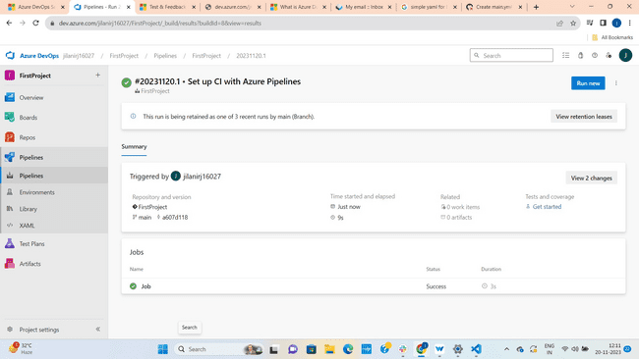



Now job is successful.

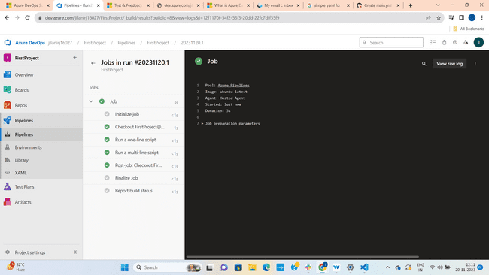

By clicking on Initialize Job You can see Pool: Azure pipelines and Image : Ubuntu-Latest (we have selected these and the time of writing the code)

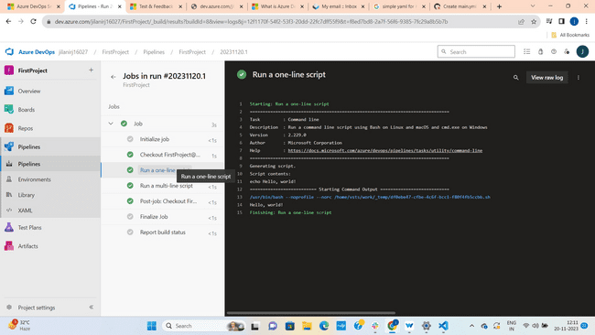



Here you can see Script content is Hello World and you can see Starting Command Output is also Hello World. It means our output is successful.